Kyama Swim School
kyamaswimschool@gmail.com
Term 3 - 14 April - 18 June 2015

Course name | Tuesday | Wednesday | Thursday | Price
 | 14 Apr - 16 Jun  except 9 June  (9 sessions) | 15 Apr - 17 Jun  (10 sessions) | 16 Apr - 18 Jun  except 14 May  (9 sessions)
Mini Squad |  | 3:30 - 4:30 |  | $1100 (1 x week)
Fitness |  | 4:30 - 5:30 |  | $1100 (1 x week)
Junior Squad | 3:30 - 5:00 |  | 3:30 - 5:00 | $1100 (1 x week)  $2200 (2 x week)
Senior Squad | 3:30 - 5:15 |  | 3:30 - 5:15 | $1100 (1 x week)  $2200 (2 x week)

Kyama Swim School - Course Description

1. Mini squad (1 hour) 8 - 11yrs
Mini squad is a transition from learn to swim to squad level. To enrol in this course children must have good technique in Freestyle, Backstroke and Breaststroke and be able to swim 50m of each stroke continuously. At this level Butterfly will be introduced.

2. Fitness squad (1 hour) 12+yrs
This squad is open to all secondary students. We will concentrate on stroke correction and building fitness. The program will be tailored to the squad needs.

3. Junior competitive squad (1hr 30min) 10 yrs - 13yrs
This squad is aimed at the current DC competitive squad level (U12 & U14). To enrol in this course the swimmer needs to demonstrate a high level of skill in each of the 4 competitive strokes and meet the junior Competitive squad criteria.
This squad is aimed at the current DC Competitive squad level (U12 &U14). To enrol in this course the swimmer needs to demonstrate a high level of skill in each of the 4 competitive strokes and meet the Junior Competitive Squad criteria.

4. Senior competitive squad (1hr 45 min) 12+yrs
This squad squad is aimed at the current DC Competitive squad level (U16 & U20) to enrol in this course the swimmer needs to demonstrate a high level of skill in each of the 4 competitive strokes and meet the Senior Competitive Squad criteria.

Swimmer Information

Child’s Name: ___________________________________________________________
D.O.B.: _____/_____/_______ Age: _______________ M / F
Address: ____________________________________________________________________
Home Telephone: ____________________ Mobile Number: _____________________
Email: _________________________@______________
Does your child have any allergies, medical conditions or physical limitations that we should be aware of? If so, please indicate: __________________________________________________
___________________________________________________________________________
Emergency contact: ______________________________ Phone: _______________________

Course Enrolment

I wish to enrol my child for the following courses (please tick all that apply):
⃝ Mini Squad ⃝ Fitness Squad ⃝ Junior Squad ⃝ Senior Squad

Day(s) ________________ Time ___________________Course Fee: _____________
Day(s) _________________Time ___________________Course Fee: _____________
Total: __________________
Payment Method: Cheque made payable to “Kyama Swim School Ltd.” and hand this application form to the Main Office. Please write the student’s name on the back of the cheque.
*Each class requires a minimum of 12 participants
Declaration

I/We agree to allow the participant to attend Kyama Swim School Classes and confirm that the information given above is true and correct. If my application is successful, I/we shall be fully responsible for the payment of all the expenses. Services Provider –Kyama Swim School Limited, its holding companies, their officers, employees, servants, agents or licensees, shall not be liable or responsible for any loss, injury, damages, claims, cost or expenses whatsoever, which may be sustained by the participant and/or any such helpers and/or parents and/or guardians and/or any other lesson companion who has/have been staying at venue, arising out of and/or in connection with Kyama Swim School Ltd Classes.

Parent’s Name: __________________________Signature: __________________________ Date: ________________________

Please note: While these activities are being held at the College, Discovery College does not guarantee the quality of 3rd party programmes and providers. We urge parents to carefully interview and check references before enrolling. Distribution of materials is simply for informational purposes and does not constitute a recommendation or endorsement.

Kyama Swim School - About Us

Coaching Philosophy
At Kyama Swim School we are committed to providing a program that encourages every student to reach their potential.
To become a great swimmer we believe you need a strong skill base. The foundation and development of technique in all 4 strokes is taught from Mini Squad right through to Senior Competitive. Once stroke technique is perfected, swimmers can progress to swimming longer distances, concentrating on fitness and endurance.
Our goal is for each student to share our love of swimming, and embrace the challenges and rewards of this great sport!

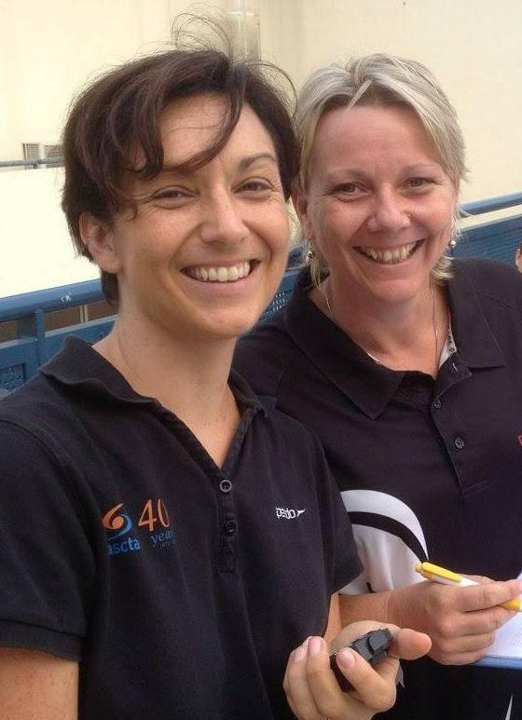

Kylie Wilson - Coach

Experience - With over 10 years of experience coaching in Hong Kong, Kylie has been a swim coach since 2005. Kylie has a wide range of experience having coached Infant and Preschool aquatics; primary school swim programs at DBIS and Discovery College, and after school Learn to Swim with Aqua Gym and ESL. Most recently she has coached the Discovery College School team overseeing the Junior Competitive Squad.

Qualifications
AUSTSWIM Teacher of Infant and Preschool Aquatics
AUSTSWIM Teacher of Swimming and Water Safety
AUSTSWIM Assessor
Swim Australia Teacher of Competitive Swimming
ASCTA Bronze Coach Licence (International)
St John's Ambulance CPR & First Aid

Amanda Walsh - Coach

Experience - Amanda has been a swim coach since 2002 and has taught in Australia, Qatar and Hong Kong. Over the past 13 years she has coached all levels of swimming from Infant and Preschool aquatics; primary school swim programs at DBIS and Discovery College, and after school Learn to Swim with Aqua Gym and ESL. Currently she coaches the Discovery College School team as Head coach of their Competitive program.

Qualifications -
AUSTSWIM Teacher of Infant and Preschool Aquatics
AUSTSWIM Teacher of Swimming and Water Safety
AUSTSWIM Teacher of Towards Competitive Strokes
Swim Australia Teacher of Competitive Swimming
ASCTA Bronze Coach Licence (International)
St John's Ambulance CPR & First Aid

